Patterns in whole number
A pattern is a sequence of numbers or picture.
We can arrange numbers in elementary shapes consisting of dots.
- Every number can be arranged as a line.
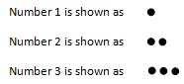
- Some numbers like 3, 6 and 10 can be arrange as a triangle.
3. Some numbers like 4, 9 and 16 can be arrange as a square
4. Some numbers like 6, 8 and 10 can be arrange as a rectangle.
Observe the following table.
Number | Line | Triangle | Square | Rectangle
2 | YES | NO | NO | NO
3 | YES | YES | NO | NO
4 | YES | NO | YES | YES
5 | YES | NO | NO | NO
6 | YES | YES | NO | YES
7 | YES | NO | NO | NO
8 | YES | NO | NO | YES
9 | YES | NO | YES | NO
10 | YES | YES | NO | YES

Patterns observations:
- Multiply 3 by 9, 99, 999, 9999. Study the pattern.
Solution: 3 x 9 = 3 x (10 – 1) = 27
3 x 99 = 3 x (100 – 1) = 297
3 x 999 = 3 x (1000 – 1) = 2997
3 x 9999 = 3 x (10000 – 1) = 29997

- Observe the following pattern.
44 x 5 = 44 x 10/2 = 22 x 10 = 220 x 1
44 x 10 = 44 x 20/2 = 22 x 20 = 220 x 2
44 x 15 = 44 x 30/2 = 22 x 30 = 220 x 3
44 x 20 = 44 x 40/2 = 22 x 40 = 220 x 4

Questions: Write down the first seven numbers that can be arranged as triangles, e.g. 3, 6, ...
Solution:
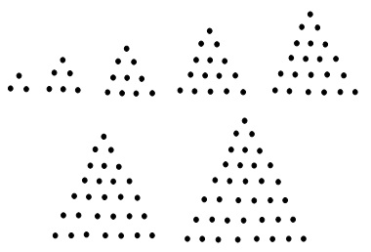
Threfore, first 7 numbers which can be arranged as triangles are 3, 6, 10,15, 21, 28, 36,
- Study the pattern:
1 × 8 + 1 = 9
12 × 8 + 2 = 98
123 × 8 + 3 = 987
1234 × 8 + 4 = 9876
12345 × 8 + 5 = 98765
Write the next two steps. Can you say how the pattern works?
(Hint: 12345 = 11111 + 1111 + 111 + 11 + 1).
Solution:
123456 x 8 + 6 = 987648 + 6 = 987654
1234567 x 8 + 7 = 9876536 + 7 = 9876543
Yes, the pattern works.
123456 = 111111 + 11111 + 1111 + 111 + 11 + 1
123456 x 8 = (111111 + 11111 + 1111 + 111 + 11 + 1) x 8
= 111111 x 8 + 11111 x 8 + 1111 x 8 + 111 x 8 + 11 x 8 + 1 x 8
= 888888 + 88888 + 8888 + 888 + 88 + 8 = 987648
123456 x 8 + 6 = 987648 + 6 = 987654

